

NASA’s Asteroid Data Hunter

User Guide

# 

Preface

About This Guide

Intended Audience

Revision History

Installation Procedures for Windows

Prerequisites

Security

Installation

Uninstall the Application

Run the Application

Installation Procedures for Mac

Prerequisites

Security

Installation

Uninstall the Application

Run the Application

View Dashboard (Application Homepage)

Select Data Files to Hunt

Start Hunting Data

Display Data Hunt Results

View Search History

Filter Search Data

View Search Details

Submit to MPC

Report New Comet

View Data on the Sky Page

Filter Sky Data

# 

# 

# Preface

## About This Guide

Welcome to the Asteroid Data Hunter Application user guide. Please use this guide as a starting point and reference for all functions and capabilities of the Asteroid Data Hunter Application.

## Intended Audience

This guide is intended for the end user of the Asteroid Data Hunter Application. As such, it will address basic functionality and intended use of the Asteroid Data Hunter Application.

## Revision History

This is the first revision of the end-user manual for the Asteroid Data Hunter Application.

# Installation Procedures for Windows

## Prerequisites

Please make sure the following prerequisites have been met:

* Must be run on Windows 7 or higher (using Parallels on a Mac will not work)
* Your computer must have at least 3 GB of ram.

## Security

If you’re using windows, your computer may:

1. Inform you that you can’t install the program to a specific area because it’s been downloaded from the Internet - in which case, we suggest you install it to a folder on your desktop.
2. Inform you to “Unblock” the app so that it can be installed - please confirm and or unblock that app so that it can properly be installed.

Please note that this is an artifact of your computers setting, and not all computers will display these messages.

## Installation

The installation for the application is pretty straight forward. It is assumed that the user is using Windows 7 or above, and the machine has at least 3GB of RAM.

Once you get the installation file "**ADH - Windows Installer.zip**", please unzip it to your desktop, then go into its sub directory "**installer-dist**", and double click "**Asteroid Data Hunter Installer.bat**" to initiate the installation process.

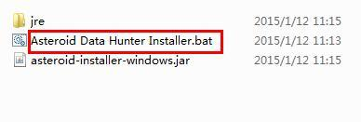

It will start the command line tool.

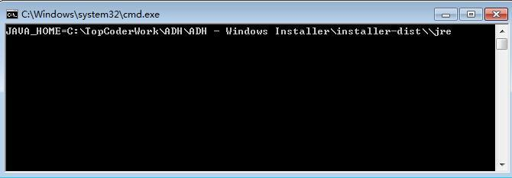

Then the installation start page will be presented.

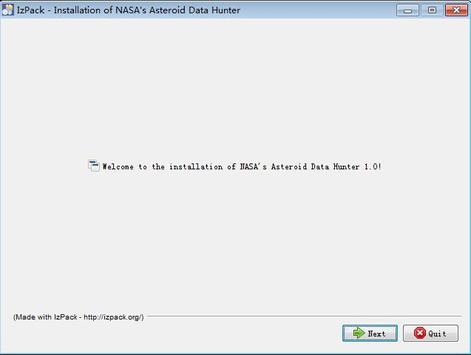

Click the "Next" button twice, you'll see the license agreement page. By default, the "Next" button is disabled. You have to check the "I accept the terms of this license agreement" option to enable the "Next" button.

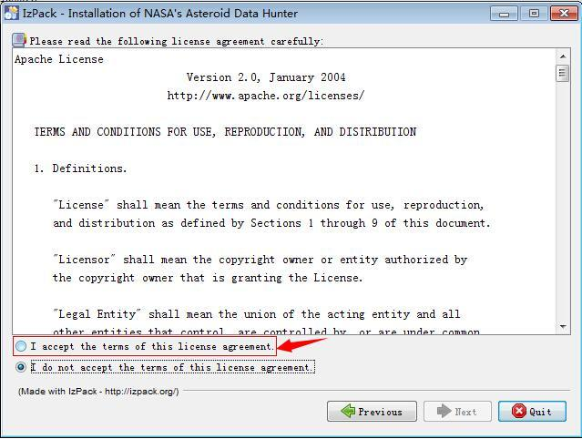

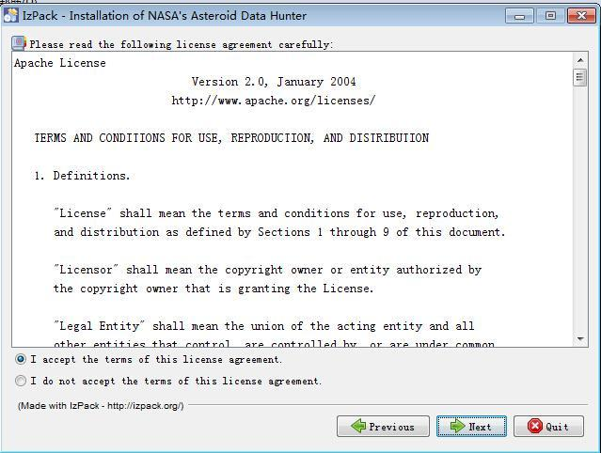

Click the "Next" button to proceed. Then it will allow the user to select the installation path. Click the "Browse..." button to change the installation path.

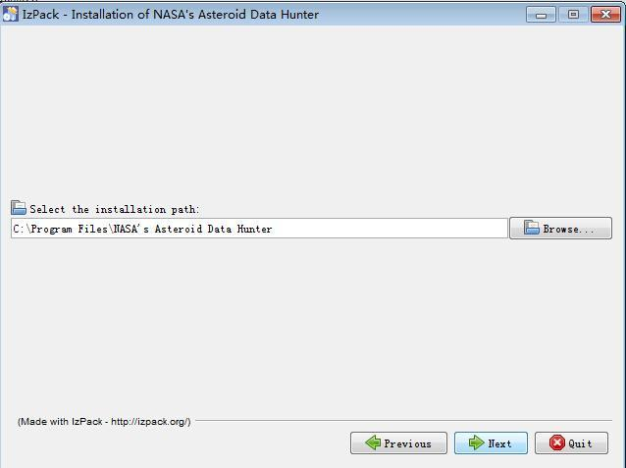

After selecting a path (e.g. C:\NASA), click the "Next" button. It will display a warning popup, click "Yes". Then the warning popup will be dismissed.

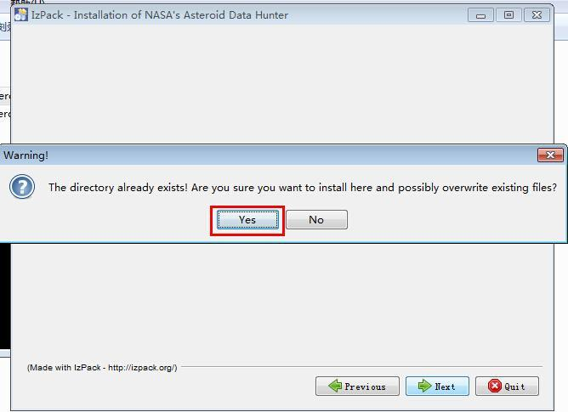

Click the "Next" button. It will display pre-selected packs which need to be installed.

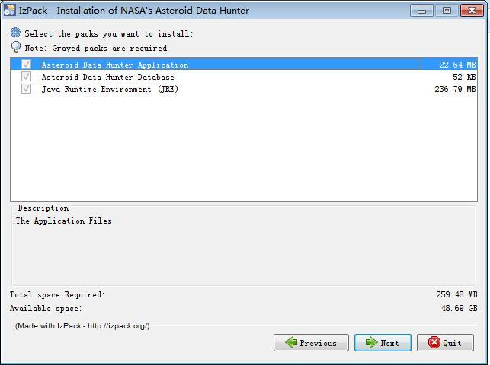

Click the "Next" button. It will start to install the app. The progress screen looks like:

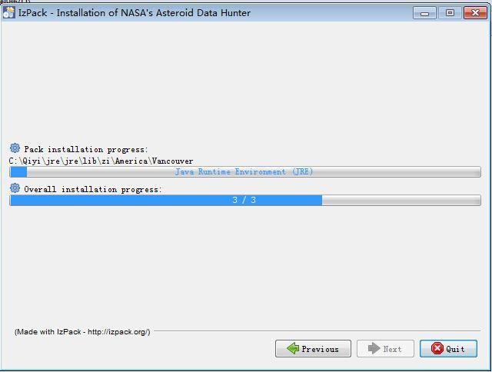



Wait for several minutes, once it is done installing, you'll see the success message.

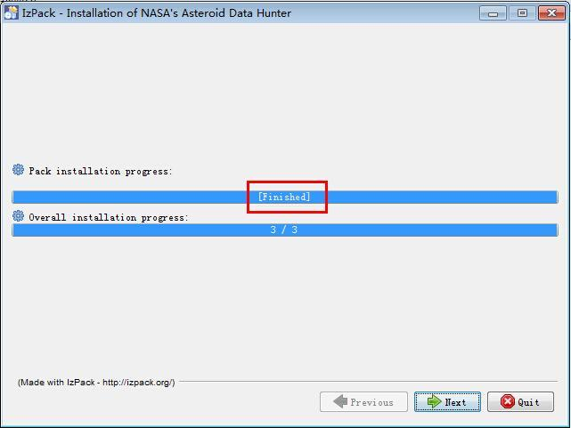

Optionally, you can click the "Next" button to set shortcuts or just click the "Quit" button to quit the installation.

You can see that the application is installed under the chosen path. Go into the chosen path ("C:\NASA" in this case), the installed files and folders look like below:

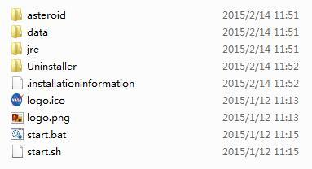

## Uninstall the Application

To uninstall the application, navigate to the folder where you installed the app. Go to the “Uninstall” sub-directory and click “Uninstaller.jar” to un-install the app.

## Run the Application

Once the application is installed, it's time to run it. Go into the installation path, then double click the "**start.bat**" file to run the application.

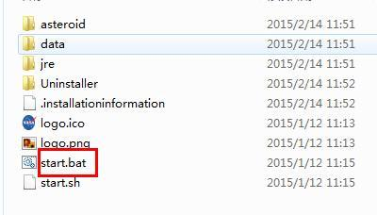

It will start the command line tool and then the application will be opened in the default browser.

**NOTE: Please make sure to keep the command line window open when using the app, otherwise the app will not function.**

# Installation Procedures for Mac

## Prerequisites

Please make sure the following prerequisites have been met:

* Must be run on Mac OS 10.10.2 or higher
* Your computer must have at least 3 GB of ram.

## Security

If you’re using windows, your computer may:

1. Inform you that you can’t install the program to a specific area because it’s been downloaded from the Internet - in which case, we suggest you install it to a folder on your desktop.
2. Inform you to “Unblock” the app so that it can be installed - please confirm and or unblock that app so that it can properly be installed.

Please note that this is an artifact of your computers setting, and not all computers will display these messages.

## Installation

The installation for the application is pretty straight forward. It is assumed that the user is using Mac OS 10.10.2 or above, and the machine has at least 3GB of RAM.

Once you’ve downloaded theinstallation file, please unzip it to your desktop, then go into its sub directory and double click "**asteroid-installer-linux.jar**" to initiate the installation process.

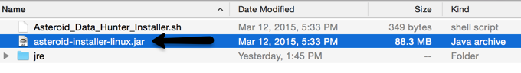

Then the installation start page will be presented.

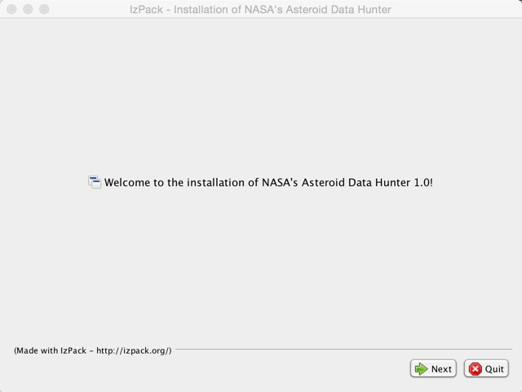

Click the "Next" button twice, you'll see the license agreement page. By default, the "Next" button is disabled. You have to check the "I accept the terms of this license agreement" option to enable the "Next" button.

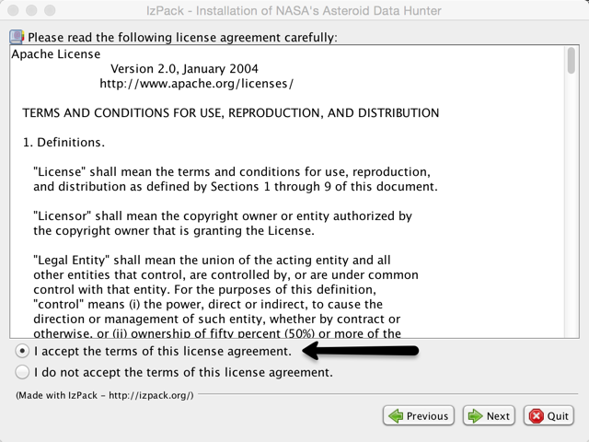

Click the "Next" button to proceed. Then it will allow the user to select the installation path. Click the "Browse..." button to change the installation path.

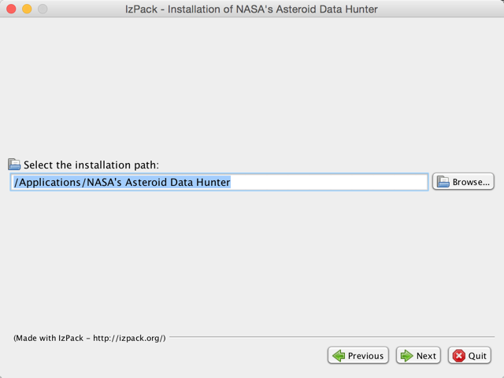

After selecting a path, click the "Next" button. It will display a warning popup, click "Yes". Then the warning popup will be dismissed.

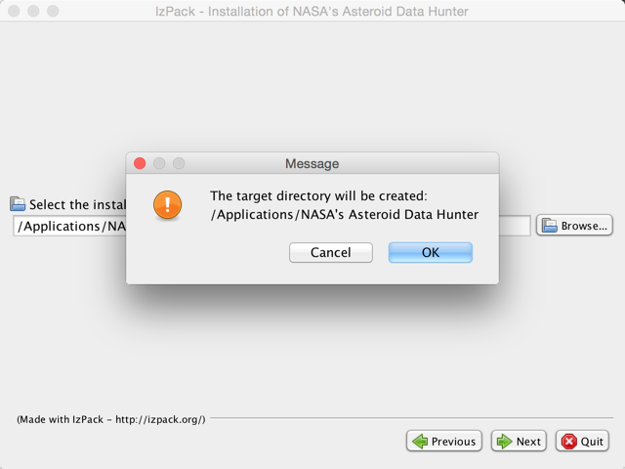

Click the "Next" button. It will display pre-selected packs which need to be installed.

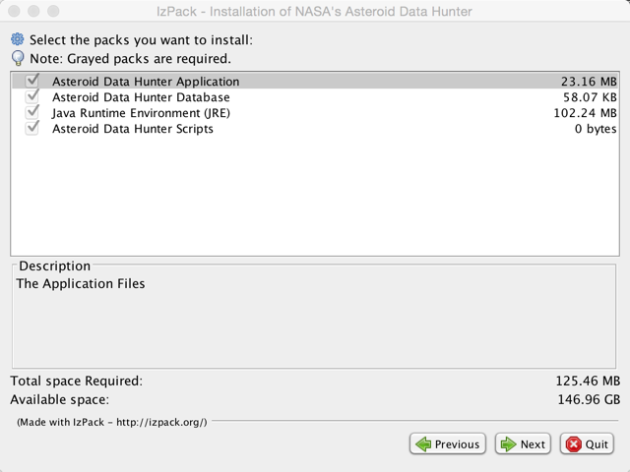

Click the "Next" button. It will start to install the app. Wait for several minutes, once it is done installing, you'll see the success message.

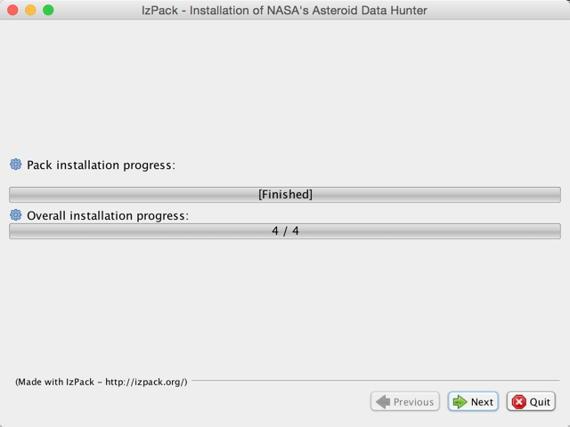

## Uninstall the Application

To uninstall the application, navigate to the Application folder, and remove the directory where you installed the application.

## Run the Application

Once the application is installed, it's time to run it. Go to Finder, and enter “Terminal”. The Terminal app will then launch. Go to the Applications folder, locate the app folder, grab start.bat, and drag “start.bat” into the terminal window. This will then launch the application within your default browser.

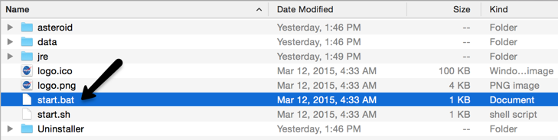

**NOTE: Please make sure to keep the terminal window open when using the app, otherwise the app will not function.**

# **View Dashboard (Application Homepage)**

The homepage will be displayed after launching the application. There will be 3 tabs available: DASHBOARD, SEARCH and SKY. The default tab is "DASHBOARD", which is the homepage of the application.

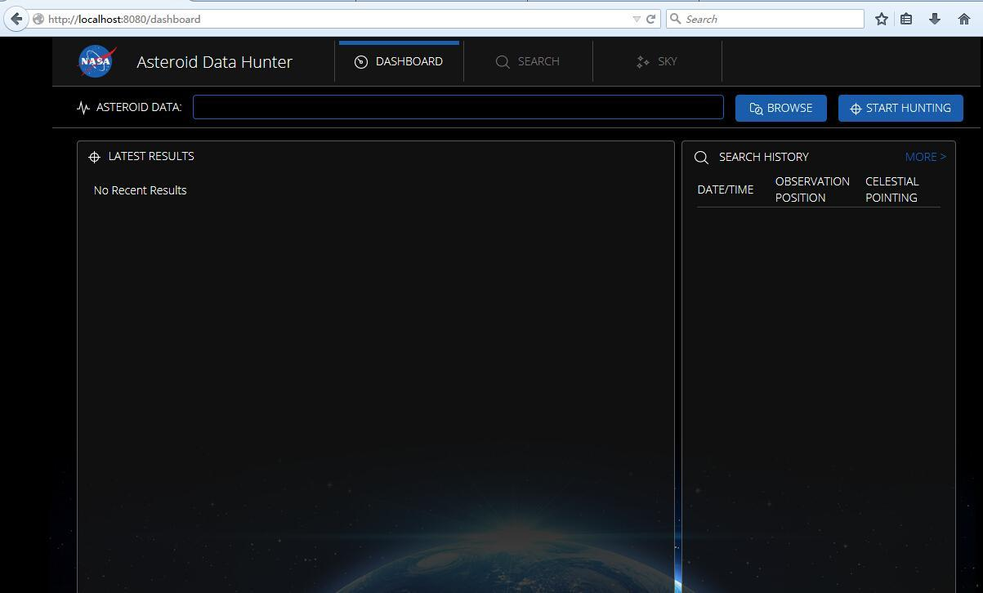

## Select Data Files to Hunt

The user can click the "BROWSE" button to select data files to hunt data. It is required that the user has to select exactly 4 files one time.



In order to select multiple files, you'll need to hold the "Ctrl" button (for Windows) or the "Command" button (for Mac) in the files browser.

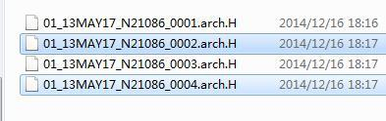

After selecting 4 files successfully, it will display the chosen files name (*comma separated*) in the text field.

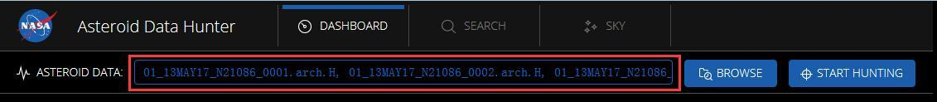

## Start Hunting Data

The user can click the "START HUNTING" button to start data hunting after selecting 4 data files.



It will display the data hunting progress with a percent indicator.

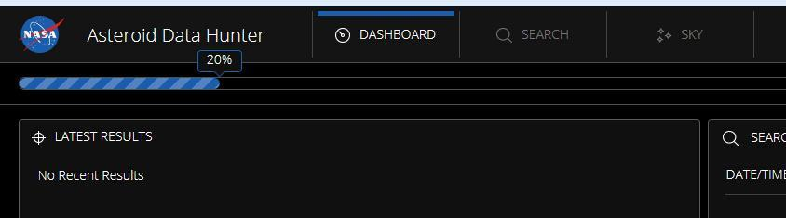

When the data hunt process is finished, it will display the results. It looks like:

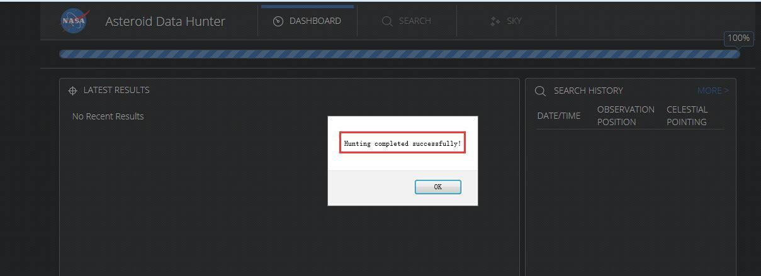

## Display Data Hunt Results

Clicking "OK" will close the popup. It will then display the data hunt results. The latest results section and search history section will be updated with hunt data.

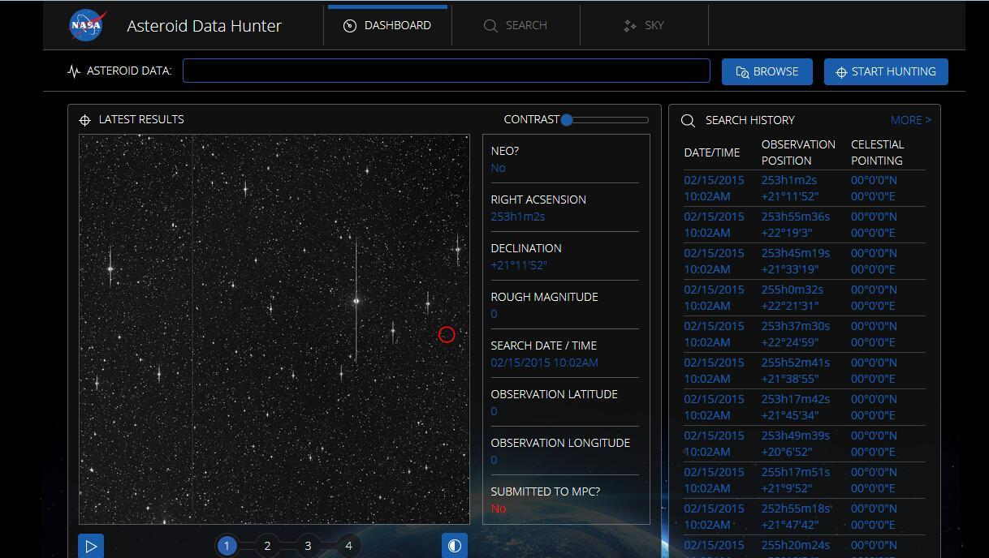

The user can click any number button to view the image: 

The user can hover the cursor on any point of the image to zoom in:

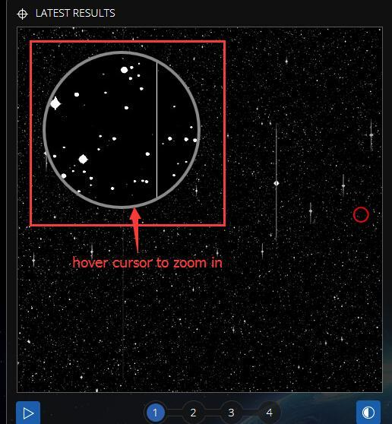

The user can click  button to automatically play all 4 images in order. After that, the Play button will change to the Pause button which can pause the automatic playing: 

The user can click  button to invert the image.

The user can adjust the contrast using the slide bar: 

There will be a "SEARCH HISTORY" section displayed with the hunt data. The user can click "MORE>" button to view more results. Each row in the table can be clicked to view its details. Please refer to chapter 4.2 for more details.

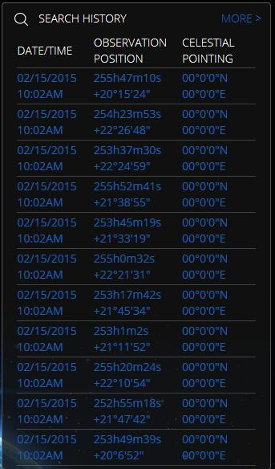

# View Search History

The user can view search history by selecting the "SEARCH" tab. By default, all data will be displayed and sorted by Date in descending order.

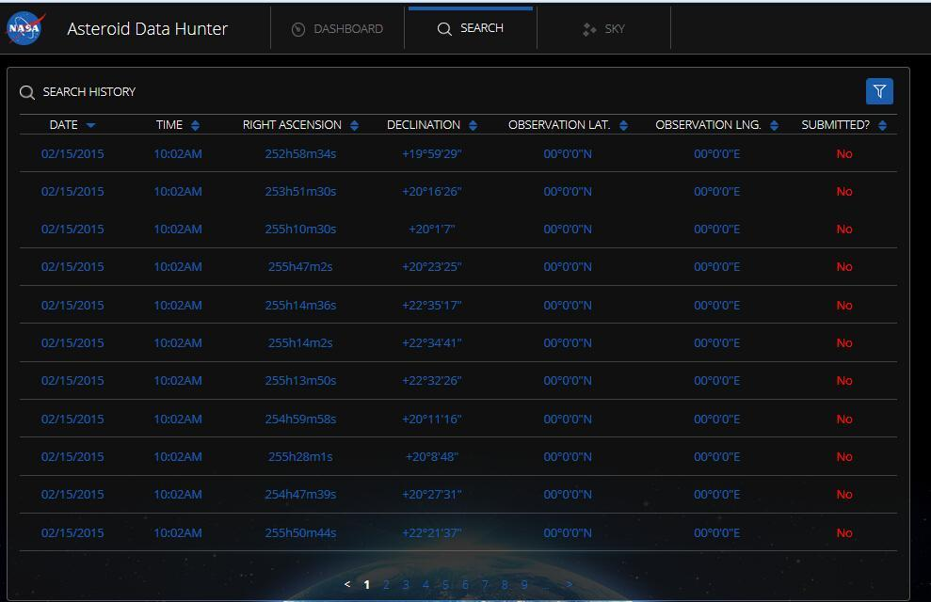

There is a pagination which can be used for navigating to different pages. The data can be sorted in ascending or descending order by each column header. The current sorting rule is indicated by the arrow direction next to the column header (Arrow down means descending, arrow up means ascending). There is also a filter which can filter by different filter criteria. Please refer to the chapter 4.1 for more details. The user can choose to view search details by clicking any row in the table. Please refer to the chapter 4.2 for more details.

## Filter Search Data

By default, the filter section is not shown. Clicking the "Filter" icon will toggle the filter section:

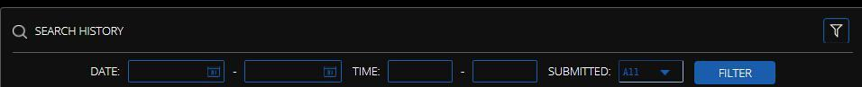

The data format of each option will follow the next table.

|  |  |  |  |
| --- | --- | --- | --- |
| **Data Element** | **Description** | **Format** | **Required?** |
| Start Date | The start date of the search. | "MM/DD/YYYY" | N |
| End Date | The end date of the search. | "MM/DD/YYYY", "Start Date" must not be later than "End Date" if both are presented. | N |
| Start Time | The start time of the search. | "hh:mm" AM/PM. | N |
| End Time | The end time of the search. | "hh:mm" AM/PM, "Start Date/Time" must not be later than "End Date/Time" if both are presented. | N |
| SUBMITTED | Whether the search is submitted or not. | Possible values: Yes, No, All.  Default value is "All". | Y |

The user can click the "Filter" button to filter the data.

## View Search Details

The search details look like:

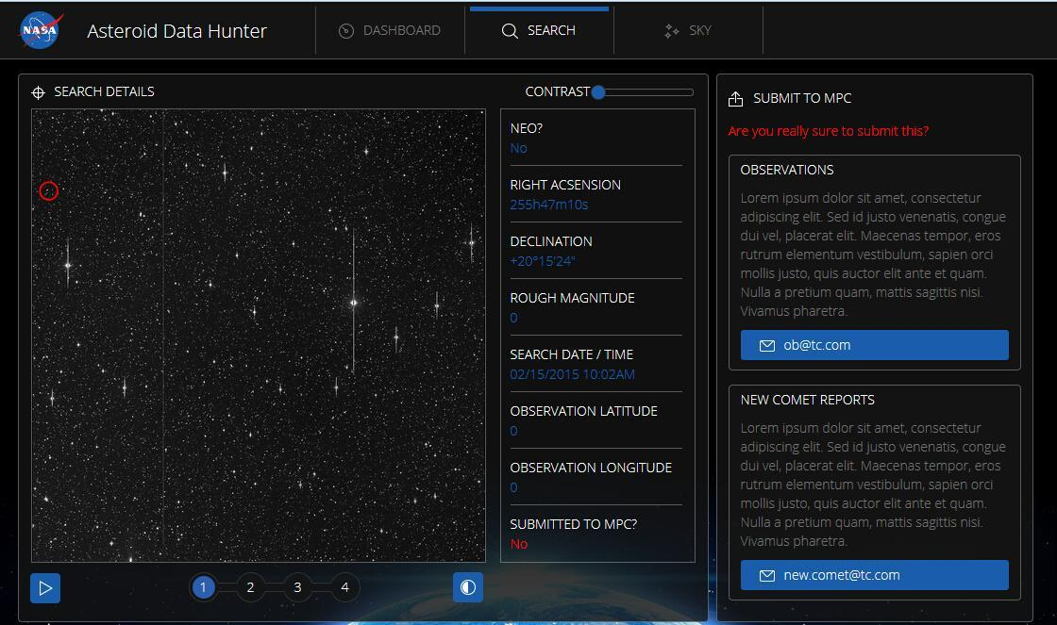

This screen looks similar to the dashboard except the right section, which can be used to submit to MPC and report new comet. Please refer to chapters 4.3 and 4.4 for more details.

The user can hover the cursor on any point of the image to zoom in:

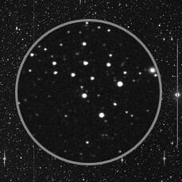

## Submit to MPC

The user can click E-mail address in the "OBSERVATIONS" section to submit the observations to MPC.

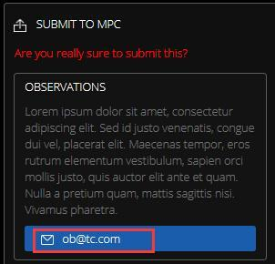

It will compose an E-mail to this e-mail address.

## Report New Comet

The user can click E-mail address in the "NEW COMET REPORTS" section to report new comet.

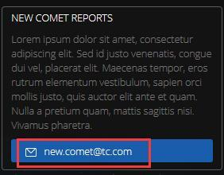

It will compose an E-mail to this e-mail address.

## View Data on the Sky Page

The user can view data on the SKY page by selecting the "SKY" tab. By default, all data of the sky will be displayed and sorted by "OBJECT DESIGNATION" in ascending order.

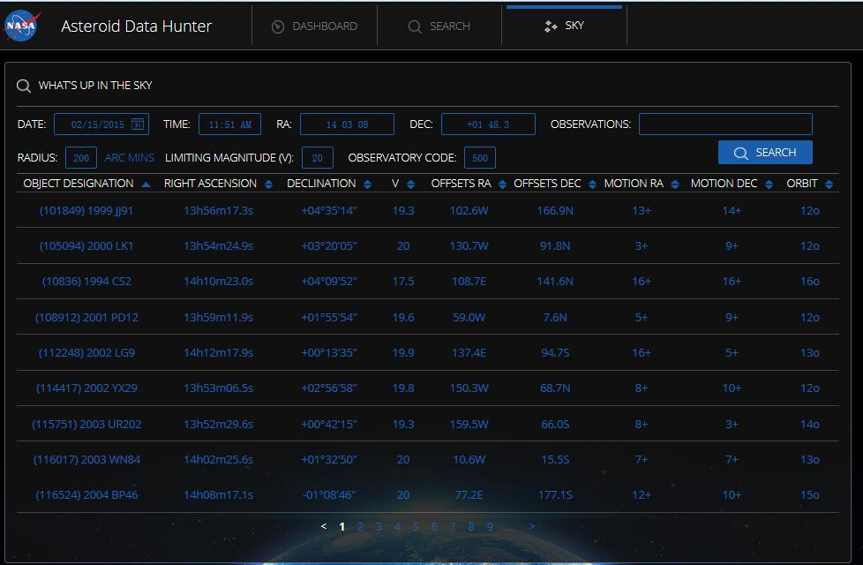

The data can be sorted in ascending or descending order by each column header. The current sorting rule is indicated by the arrow direction next to the column header (Arrow down means descending, arrow up means ascending). There is a pagination which can be used for navigating to different pages. There is also a filter section which can filter data by different filter criteria. Please refer to the chapter 5.1 for more details.

## Filter Sky Data

There will be some filter options displayed in the "Filter" section:



The user can input the filter criteria and click the "SEARCH" button to filter data. The results will be updated based on entered filter criteria.